**Name: Adwait Purao**

**UID: 2021300101**

**Batch: B2**

**Experiment 7**

**Aim:** To Create an ftp Server using vsftpd

**Theory:**

FTP Server:

• The primary purpose of an FTP server is to allow users to upload and download files.

• An FTP server is a computer that has a file transfer protocol (FTP) address and is

dedicated to receiving an FTP connection.

• FTP is a protocol used to transfer files via the internet between a server (sender) and

a client (receiver).

• An FTP server is a computer that offers files available for download via an FTP

protocol, and it is a common solution used to facilitate remote data sharing between

computers.

• An FTP server is an important component in FTP architecture and helps in

exchanging files over the internet. The files are generally uploaded to the server

from a personal computer or other removable hard drives (such as a USB flash drive)

and then sent from the server to a remote client via the FTP protocol.

• An FTP server needs a TCP/IP network to function and is dependent on the use of

dedicated servers with one or more FTP clients. In order to ensure that connections

can be always established from the clients, an FTP server is usually switched on; up

and running 24/7.

• An FTP server is also known as an FTP site or FTP host.

• All file transfer protocol site addresses begin with ftp://. FTP servers usually listen for

client connections on port 21 since the FTP protocol generally uses this port as its

principal route of communication.

• FTP runs on two different Transmission Control Protocol ports: 20 and 21. FTP ports

20 and 21 must both be open on the network for successful file transfers.

**Advantages of FTP:**

1. Ease of use: FTP is simple to use and does not require any special software. Most

operating systems have built-in FTP clients, making it easy to transfer files.

2. File transfer speed: FTP allows for fast transfer speeds, which is important when

transferring large files or large amounts of data.

3. Compatibility: FTP is compatible with a wide range of devices and operating systems,

making it a flexible choice for file transfer.

4. Security: FTP supports encryption and user authentication, making it a secure way to

transfer files.

**Disadvantages of FTP:**

1. Lack of security: While FTP supports encryption and user authentication, it is still

vulnerable to attacks such as password sniffing and spoofing.

2. Limited functionality: FTP has limited functionality compared to other file transfer

protocols, such as SFTP or FTPS.

3. Firewall issues: FTP can be blocked by firewalls, which can make it difficult to

transfer files between networks.

4. Lack of reliability: FTP does not have built-in error checking or recovery mechanisms,

so files can become corrupted or lost during transfer.

**VSFTPD:**

vsftpd stands for Very Secure FTP Daemon. It is an open-source, lightweight, and secure FTP

server software that runs on Unix-like operating systems such as Linux, FreeBSD, and Solaris.

vsftpd is widely used because of its focus on security, simplicity, and performance.

Some of the features of vsftpd include:

1. Security: vsftpd is designed with security in mind and has built-in support for SSL/TLS

encryption, virtual users, and IP-based access control.

2. Performance: vsftpd is designed to be lightweight and efficient, with support for

high-speed data transfers.

3. Simplicity: vsftpd is easy to configure and use, with a simple configuration file and a

user-friendly command-line interface.

4. Customization: vsftpd is highly customizable, with support for a wide range of

configuration options and plugins.

vsftpd is a reliable and secure FTP server software that is well-suited for small to mediumsized organizations. It is a popular choice for those who require a lightweight and efficient

FTP server with strong security features.

**Installation and Configuration:**

• **Installing vsftpd and then setting up the .conf files for ftp server**

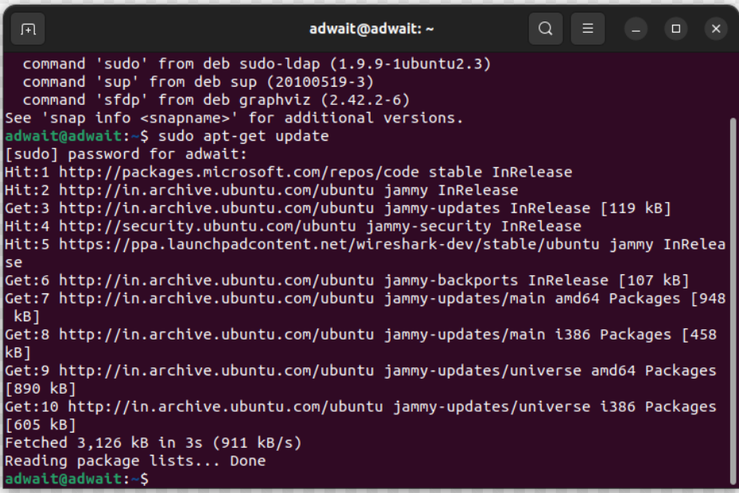

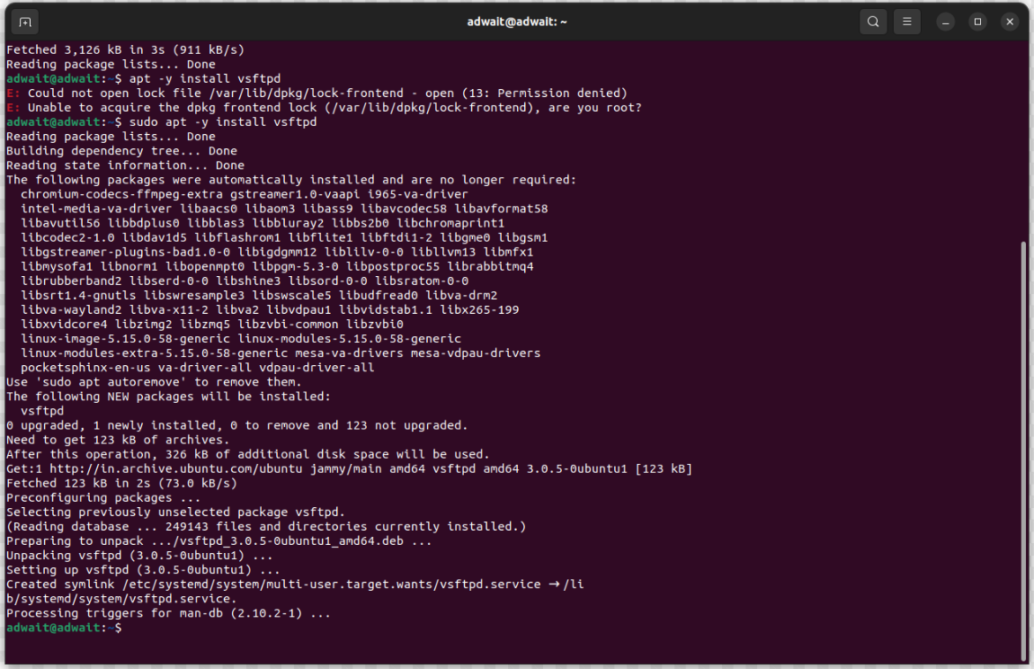

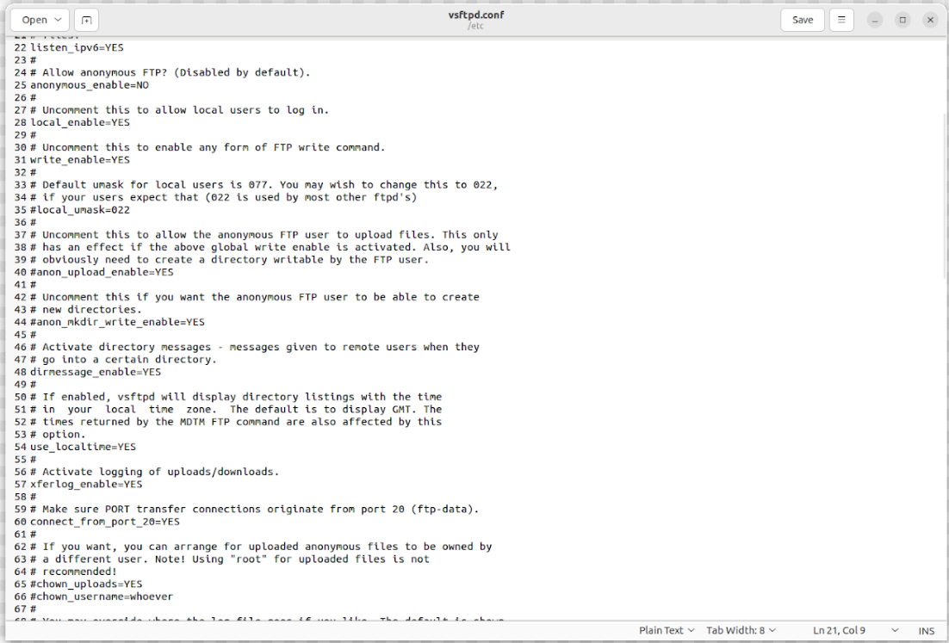

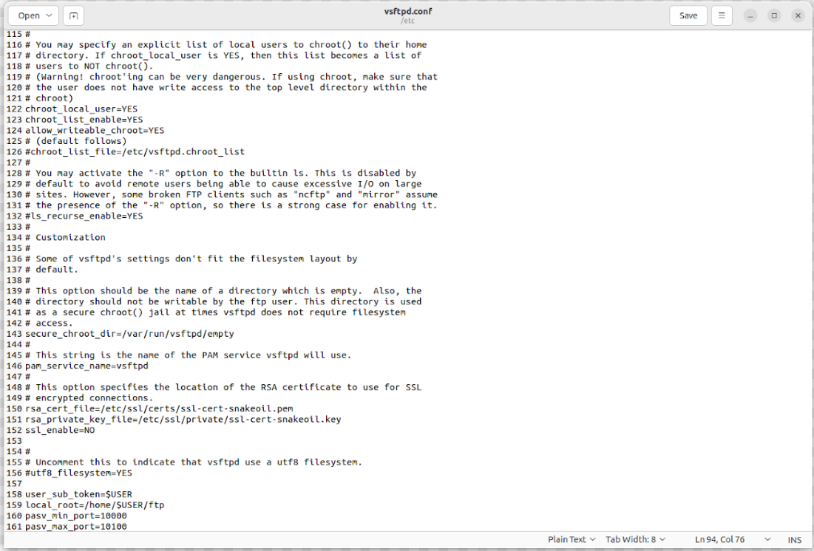



Add user student

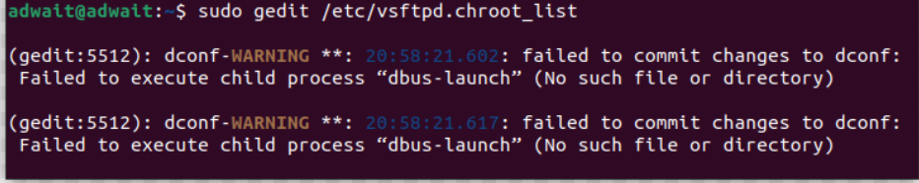

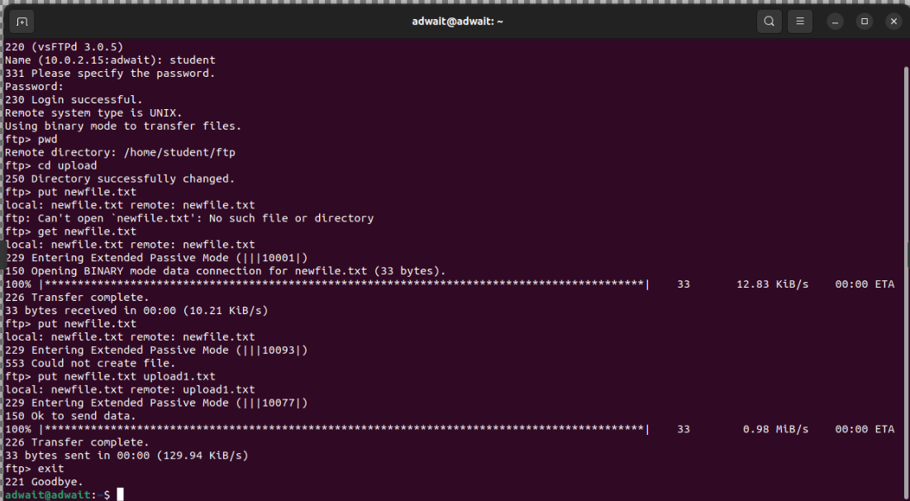

**Conclusion:**

Through this experiment, we gained knowledge about the File Transfer Protocol (FTP) and its server, as well as the vsftpd package which facilitates the creation of an FTP server. We also learned about the process of sending and receiving files between different users using IP addresses, and how this can be accomplished from both server perspectives.